**DUGWAY PROVING GROUND  
  
THE NEW GROOM LAKE?**

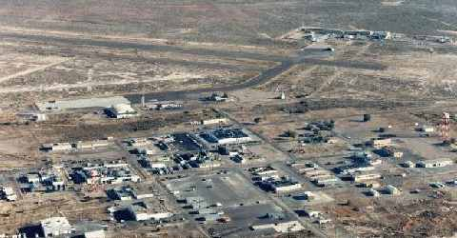

Dugway Proving Ground is located 80 miles southwest of Salt Lake City and covers an area of approximately 800,000 acres in the Great Salt Lake Desert. It is by far the most secretive facility in Utah as well as the most controversial. Many residents feel threatened and unsure of its close location to Salt Lake City, especially because of the type of testing that takes place there.

The primary mission of Dugway Proving Ground is to plan, conduct, analyze, and report the results of technical tests and studies; especially in the areas of chemical defense, biological defense, incendiary, smoke and obscurant systems, and environmental technology testing. Dugway also provides test expertise, services and support for all authorized customers, including United States and foreign governments, as well as non-governmental organizations. In addition, Dugway is a major range and test facility for chemical and biological defense testing and a reliance center for the U.S. Department of Defense.

With the attack on Pearl Harbor in 1941, the United States and its military forces suddenly realized a need for increased military capability in many areas, which included expanded knowledge in chemical and biological warfare.

Dugway Proving Ground was authorized to fill the need for testing weapons and defenses against chemical and biological agents. Over the years, the proving ground has undergone various name changes and periods of deactivation and reactivation.

Dugway is now part of the U.S. Army Test and Evaluation Command (TECOM), headquartered at Aberdeen Proving Ground, Maryland. TECOM is a major subordinate command of the U.S. Army Material Command, headquartered at Alexandria, Virginia. At present, Dugway Proving Ground encompasses 798,855 acres. In addition to chemical and biological defensive testing and environment characterization and remediation technology testing, Dugway is the Defense Department's leader in testing battlefield smokes and obscurants. The installion currently consists of more than 600 buildings with a total value of more than $240 million.

**UFOs at Dugway?**

Lately there has been an increase in activity at the Utah facility, both on the ground and in the airspace above Dugway. Reported last year, was the construction of a new 15,000 feet runway which is now known to be for the testing of NASA's next generation space shuttles, including the X-33. Also, unusual aerial objects emitting mysterious vapor contrails lends support to Dugway being a secret test facility for new aircraft.

Security at the installation has also been increased quite dramatically. Warning signs have been established along the perimeter of the base and if someone happens to wander to close to the restricted zones, expect to see unmarked "black" helicopters challenge your presence in the area.

It has also been revealed that an unusual facility within Dugway may house experimental craft, possibly of alien origin. During the 1950s and 1970s, the facility was constantly under armed guard. During this time period, convoy trucks had been seen entering the hangar with their cargo covered by tarpaulins. One truck was seen which was carrying something oval or circular in shape and being about 30 feet wide. The truck was accompanied by five men. Could this have been a flying disc-shaped craft? Three concentric fences were later built around the hangar.

Rumors persist as to what is housed in the hangar, a more common one being that it is a storage facility for a SLR-1 portable nuclear reactor. However, there is unusual evidence which may suggest that the flying disc was of a very secretive nature. The five men who were seen with the truck all happened to mysteriously die within a year of delivering the cargo to Dugway. Two of them died in a single plane crash from Chicago to Denver. The third died in an auto wreck when his car fell off a cliff in Northern California, presumably because of brake failure. The fourth committed suicide by hanging himself with a necktie, for no apparent reason. The fifth man simply was reported missing one day after leaving home for work.

Of course, the above story could simply be disinformation, to distract people from a different project at Dugway Proving Ground. But whatever the truth, the base is alive with strange and unusual activity.