**Cockpit**

From Wikipedia, the free encyclopedia

*This article is about the flight deck of an aircraft. For other uses, see* [*Cockpit (disambiguation)*](http://en.wikipedia.org/wiki/Cockpit_(disambiguation))*.*

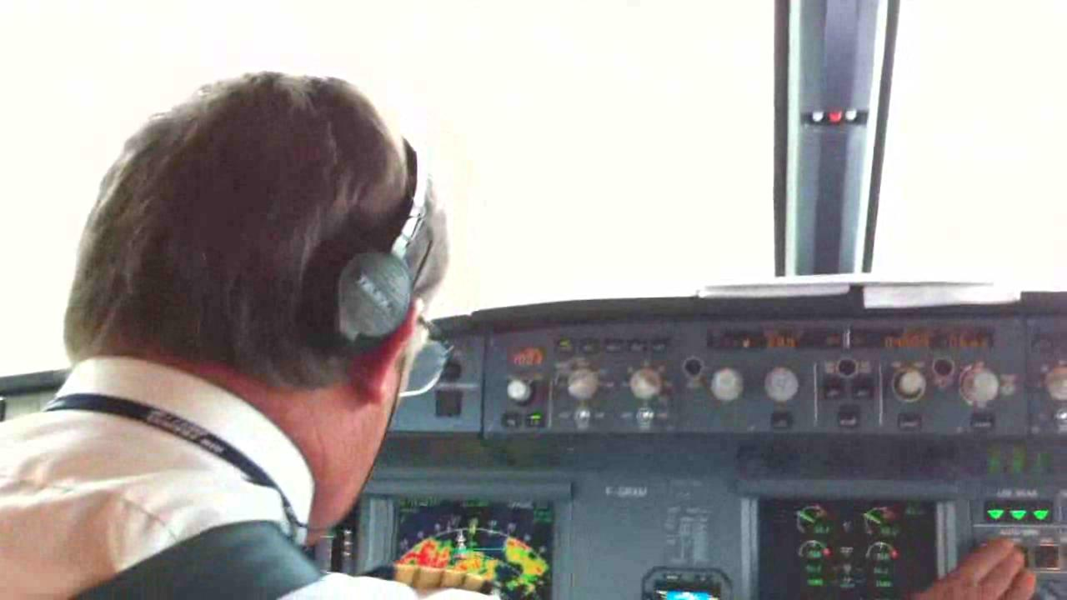

(video) View from the cockpit of an [Airbus A319](http://en.wikipedia.org/wiki/Airbus_A319) aircraft of [Air France](http://en.wikipedia.org/wiki/Air_France) during landing at [CDG](http://en.wikipedia.org/wiki/Charles_de_Gaulle_Airport)

A **cockpit** or **flight deck** is the area, usually near the front of an [aircraft](http://en.wikipedia.org/wiki/Aircraft), from which a [pilot](http://en.wikipedia.org/wiki/Pilot_in_command) controls the aircraft. Most modern cockpits are enclosed, except on some small aircraft, and cockpits on large [airliners](http://en.wikipedia.org/wiki/Airliner) are also physically separated from the cabin. From the cockpit an aircraft is controlled on the ground and in the air.

Cockpit as a term for the pilot's compartment in an aircraft first appeared in 1914. From about 1935 cockpit also came to be used informally to refer to the driver's seat of a [car](http://en.wikipedia.org/wiki/Automobile), especially a high performance one, and this is official terminology in [Formula One](http://en.wikipedia.org/wiki/Formula_One). The term is most likely related to the [sailing term](http://en.wikipedia.org/wiki/Cockpit_(sailing)) for the [coxswain](http://en.wikipedia.org/wiki/Coxswain)'s station in a [Royal Navy](http://en.wikipedia.org/wiki/Royal_Navy) ship, and later the location of the ship's rudder controls.

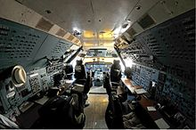

Cockpit of the [Antonov An-124](http://en.wikipedia.org/wiki/Antonov_An-124) of [Polet Airlines](http://en.wikipedia.org/wiki/Polet_Airlines).

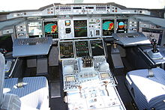

[Airbus A380](http://en.wikipedia.org/wiki/Airbus_A380) cockpit. Most Airbus cockpits are computerized [glass cockpits](http://en.wikipedia.org/wiki/Glass_cockpit) featuring [fly-by-wire](http://en.wikipedia.org/wiki/Fly-by-wire) technology. The [control column](http://en.wikipedia.org/wiki/Control_column) has been replaced with an electronic sidestick.

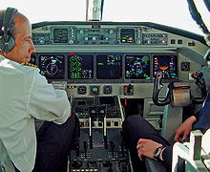

Swiss HB-IZX [Saab 2000](http://en.wikipedia.org/wiki/Saab_2000) cockpit

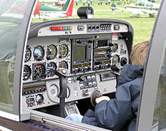

[Robin](http://en.wikipedia.org/wiki/Avions_Robin) DR400/500

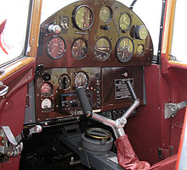

1936 [de Havilland Hornet Moth](http://en.wikipedia.org/wiki/De_Havilland_Hornet_Moth) cockpit

The cockpit of an aircraft contains [flight instruments](http://en.wikipedia.org/wiki/Flight_instruments) on an instrument panel, and the controls which enable the pilot to fly the aircraft. In most airliners, a door separates the cockpit from the passenger compartment. After the [September 11, 2001 terrorist attacks](http://en.wikipedia.org/wiki/September_11,_2001_attacks), all major [airlines](http://en.wikipedia.org/wiki/Airline) fortified the cockpit against access by [hijackers](http://en.wikipedia.org/wiki/Aircraft_hijacking).

On an airliner, the cockpit is usually referred to as the flight deck. This term derives from its use by the RAF for the separate, upper platform where the pilot and co-pilot sat in large [flying boats](http://en.wikipedia.org/wiki/Flying_boats).

**Ergonomics**

The first airplane with an enclosed cabin appeared in 1912 on the [Avro Type F](http://en.wikipedia.org/wiki/Avro_Type_F) however during the early 1920s there were many passenger aircraft in which the crew remained open to the air while the passengers sat in a cabin. Military biplanes and the first single-engine fighters and attack aircraft also had open cockpits, some as late as the [Second World War](http://en.wikipedia.org/wiki/Second_World_War) when enclosed cockpits became the norm.

The largest impediment to having closed cabins was the material the windows were to be made of. Prior to [Perspex](http://en.wikipedia.org/wiki/Poly(methyl_methacrylate)) becoming available in 1933, windows were either safety glass, which was heavy, or [cellulose nitrate (i.e.: guncotton)](http://en.wikipedia.org/wiki/Nitrocellulose) which yellowed quickly and was extremely flammable. In the mid-1920s many aircraft manufacturers began using enclosed cockpits for the first time. Early airplanes with closed cockpits include the 1924 [Fokker tri-motor](http://en.wikipedia.org/wiki/Fokker_tri-motor), the 1926 German [Junkers W.34](http://en.wikipedia.org/wiki/Junkers_W.34) transport, the 1926 [Ford Tri-Motor](http://en.wikipedia.org/wiki/Ford_Tri-Motor), the 1927 [Lockheed Vega](http://en.wikipedia.org/wiki/Lockheed_Vega), the [Spirit of St. Louis](http://en.wikipedia.org/wiki/Spirit_of_St._Louis) and the passenger aircraft manufactured by the Douglas and Boeing companies during the mid-1930s. Open-cockpit airplanes were almost extinct by the mid-1950s, with the exception of training planes, crop-dusters and [homebuilt aircraft](http://en.wikipedia.org/wiki/Homebuilt_aircraft) designs.

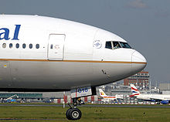

A pilot can be seen on the flight deck of this [Continental Airlines](http://en.wikipedia.org/wiki/Continental_Airlines) [Boeing 777-200](http://en.wikipedia.org/wiki/Boeing_777) as it [taxis](http://en.wikipedia.org/wiki/Taxiing) to the takeoff point at [London Heathrow Airport](http://en.wikipedia.org/wiki/London_Heathrow_Airport), [England](http://en.wikipedia.org/wiki/England).

Cockpit windows may be equipped with a sun shield. Most cockpits have windows which can be opened when the aircraft is on the ground. Nearly all glass windows in large aircraft have an [Anti-reflective coating](http://en.wikipedia.org/wiki/Anti-reflective_coating), and an internal heating element to melt ice. Smaller aircraft may be equipped with a transparent [aircraft canopy](http://en.wikipedia.org/wiki/Aircraft_canopy).

In most cockpits the pilot's control column or [joystick](http://en.wikipedia.org/wiki/Joystick) is located centrally ([center stick](http://en.wikipedia.org/wiki/Centre_stick)), although in some military fast jets and in some commercial airliners the pilot uses a [side-stick](http://en.wikipedia.org/wiki/Side-stick) (usually located on the outboard side and/or at the left).

The layout of the cockpit, especially in the military fast jet, has undergone standardization, both within and between aircraft different manufacturers and even different nations. One of the most important developments was the “Basic Six” pattern, later the “Basic T”, developed from 1937 onwards by the [Royal Air Force](http://en.wikipedia.org/wiki/Royal_Air_Force), designed to optimize pilot [instrument](http://en.wikipedia.org/wiki/Flight_instruments) scanning.

Ergonomics and human factors concerns are important in the design of modern cockpits. The layout and function of cockpit displays controls are designed to increase pilot [situation awareness](http://en.wikipedia.org/wiki/Situation_awareness) without causing information overload. In the past, many cockpits, especially in fighter aircraft, limited the size of the pilots that could fit into them. Now, cockpits are being designed to accommodate from the 1st [percentile](http://en.wikipedia.org/wiki/Percentile) female physical size and the 99th percentile male size.

In the design of the cockpit in a military fast jet, the traditional “knobs and dials“ associated with the cockpit are mainly absent. Instrument panels are now almost wholly replaced by electronic displays which are themselves often re-configurable to save space. While some hard-wired dedicated switches must still be used for reasons of integrity and safety, many traditional controls are replaced by multi-function re-configurable controls or so-called “soft keys”. Controls are incorporated onto the stick and throttle to enable the pilot to maintain a head-up and eyes-out position – the so-called Hands On Throttle And Stick or [HOTAS](http://en.wikipedia.org/wiki/HOTAS) concept,. These controls may be then further augmented by new control media such as head pointing with a [Helmet Mounted Sighting System](http://en.wikipedia.org/wiki/Helmet_mounted_display) or Direct Voice Input ([DVI](http://en.wikipedia.org/wiki/Direct_Voice_Input)). New advances in auditory displays even allow for [Direct Voice Output](http://en.wikipedia.org/w/index.php?title=Direct_Voice_Output&action=edit&redlink=1) of aircraft status information and for the spatial localization of warning sounds for improved monitoring of aircraft systems.

The layout of control panels in modern airliners has become largely unified across the industry. The majority of the systems-related controls (such as electrical, fuel, hydraulics and pressurization) for example, are usually located in the ceiling on an overhead panel. Radios are generally placed on a panel between the pilot's seats known as the pedestal. Automatic flight controls such as the [autopilot](http://en.wikipedia.org/wiki/Autopilot) are usually placed just below the windscreen and above the main instrument panel on the glareshield. A central concept in the design of the cockpit is the [Design Eye Position](http://en.wikipedia.org/wiki/Design_Eye_Position) or "DEP", from which point all displays should be visible.

Most modern cockpit will also include some kind of [integrated warning system](http://en.wikipedia.org/wiki/Bitching_Betty).

**Flight instruments**

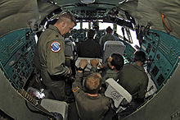

[USAF](http://en.wikipedia.org/wiki/USAF) and [IAF](http://en.wikipedia.org/wiki/Indian_Air_Force) airmen work inside the cockpit of an IAF [Ilyushin Il-76](http://en.wikipedia.org/wiki/Ilyushin_Il-76)

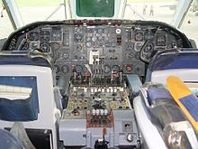

The [Vickers VC-10](http://en.wikipedia.org/wiki/Vickers_VC-10) airliner of the 1960s featured an analogue cockpit with old-style instruments.

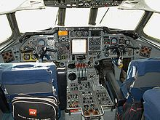

A later analogue cockpit (1970s) of a [Hawker Siddeley Trident](http://en.wikipedia.org/wiki/Hawker_Siddeley_Trident) airliner

In the modern electronic cockpit, the flight instruments usually regarded as essential are MCP, PFD, ND, EICAS, FMS/CDU and back-up instruments.

**MCP**

A [mode control panel](http://en.wikipedia.org/wiki/Mode_control_panel), usually a long narrow panel located centrally in front of the pilot, may be used to control heading, speed, altitude, vertical speed, vertical navigation and lateral navigation. It may also be used to engage or disengage both the autopilot and the auto throttle. The panel as an area is usually referred to as the "glareshield panel". MCP is a Boeing designation (that has been informally adopted as a generic name for the unit/panel) for a unit that allows for the selection and parameter setting of the different auto flight functions, the same unit on an Airbus aircraft is referred to as the FCU (Flight Control unit).

**PFD**

The [primary flight display](http://en.wikipedia.org/wiki/Primary_flight_display) is usually located in a prominent position, either centrally or on either side of the cockpit. It will in most cases include a digitized presentation of the attitude indicator, air speed and altitude indicators (usually as a tape display) and the vertical speed indicator. It will in many cases include some form of heading indicator and ILS/VOR deviation indicators. In many cases an indicator of the engaged and armed auto fight system modes will be present along with some form of indication of the selected values for altitude, speed, vertical speed and heading. It may be pilot selectable to swap with the ND.

**ND**

A navigation display, which may be adjacent to the PFD, shows the current route and information on the next waypoint, current wind speed and wind direction. It may be pilot selectable to swap with the PFD.

**EICAS/ECAM**

The Engine Indication and Crew Alerting System (used for Boeing) or Electronic Centralized Aircraft Monitor (for Airbus) will allow the pilot to monitor the following information: values for N1, N2 and N3, fuel temperature, fuel flow, the electrical system, cockpit or cabin temperature and pressure, control surfaces and so on. The pilot may select display of information by means of button press.

**FMS**

The flight management system/control unit may be used by the pilot to enter and check for the following information: flight plan, speed control, navigation control, and so on.

**Back-up instruments**

In a less prominent part of the cockpit, in case of failure of the other instruments, there will be a set of back-up instruments, showing basic flight information such as speed, altitude, heading, and aircraft attitude.

**Aerospace industry technologies**

In the U.S. the Federal Aviation Administration ([FAA](http://en.wikipedia.org/wiki/FAA)) and the National Aeronautics and Space Administration ([NASA](http://en.wikipedia.org/wiki/NASA)) have researched the ergonomic aspects of cockpit design and have conducted investigations of airline industry accidents. Cockpit design disciplines include [Cognitive Science](http://en.wikipedia.org/wiki/Cognitive_Science), [Neuroscience](http://en.wikipedia.org/wiki/Neuroscience), [Human Computer Interaction](http://en.wikipedia.org/wiki/Human_Computer_Interaction), [Human Factors Engineering](http://en.wikipedia.org/wiki/Human_Factors), [Anthropometry](http://en.wikipedia.org/wiki/Anthropometry) and [Ergonomics](http://en.wikipedia.org/wiki/Ergonomics).

Aircraft designs have adopted the fully digital “glass cockpit.” In such designs, instruments and gauges, including navigational map displays, use a user interface markup language known as [ARINC 661](http://en.wikipedia.org/wiki/ARINC_661). This standard defines the interface between an independent cockpit display system, generally produced by a single manufacturer, and the avionics equipment and user applications which it is required to support, by means of displays and controls, often made by different manufacturers. The separation between the overall display system, and the applications driving it, allows for considerable specialization and independence.

This page was last modified on 8 July 2012 at 15:27.