**Dosimeter**

From Wikipedia, the free encyclopedia



Fiber dosimeter

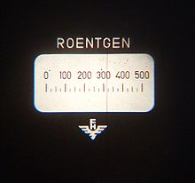

View through Fiber Dosimeter to estimate the total dose

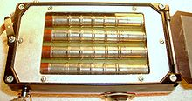

Portable Dosimeter

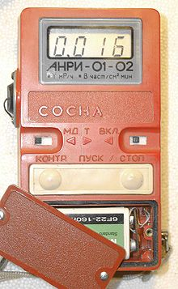

iPad Dosimeter

Dosimeters measure an individual's or an object's exposure to something in the environment — particularly to a hazard inflicting cumulative impact over long periods of time, or over a lifetime. This article concentrates on the radiation dosimeter, which measures exposure to ionizing radiation, but other dosimeters also exist, such as sound dosimeters, ultraviolet dosimeters, and electromagnetic field dosimeters.

Ionizing radiation, such as X-rays, alpha rays, beta rays, and gamma rays, remains undetectable by the senses, and the damage it causes to the body is cumulative, related to the total dose received. Therefore, workers who are exposed to radiation, such as radiographers, nuclear power plant workers, doctors using radiotherapy, workers in laboratories using radionuclides, and some HAZMAT teams are required to wear dosimeters so their employers can keep a record of their exposure, to verify that it is below legally prescribed limits.

Common types of wearable dosimeters for ionizing radiation include:

* Quartz fiber dosimeter
* Film badge dosimeter
* Thermo-luminescent dosimeter
* Solid state (MOSFET or silicon diode) dosimeter

The quartz fiber dosimeters have to be prepared, usually daily, with a positive charge from either a hand-wound or battery-powered charging unit. As the dosimeter is affected by nuclear radiation the charge leaks away causing the fiber indicator to rise up the graduated scale.

Factories prepare film-badge dosimeters for one-time use. The level of radiation absorption is indicated by a change of color on the film badge's surface, which is compared to an indicator chart.

Manufacturing processes that treat products with ionizing radiation, such as food irradiation, use dosimeters to calibrate doses. These are different from personal dosimeters because they usually must have a greater range. They often consist of small blocks of material such as perspex.

One can also carry out the dosimetry of neutron radiation with a few specialised devices such as superheated drop detectors.