**Socialism**

**Definition and Origins**

Socialism means that there is no such a thing as a private property in the country or state. So as to say that everything used for production is a property of the country or state. Socialism first came about in 1791 In France when the socialists wanted to distribute the spoils of capitalistic industrial productions. The workers then were helping the owners get rich while the owners mistreated them. Therefore, the socialists wanted to do something about this. Saint-Simon was the first person to have a vision about this ideal society. His followers, Saint-Simonians then continued his work and finally devised a system called Socialism.

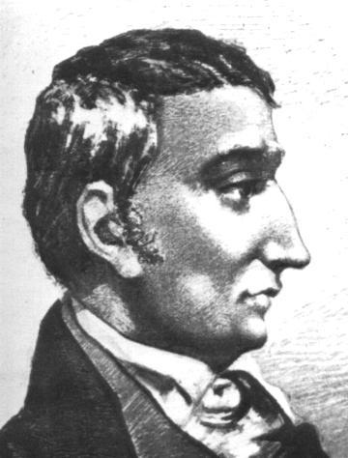

A German called Karl Marx is another person famous in the aspect of socialism as he was the person who founded modern scientific socialism known as Marxism. Marxism also helped make socialist and communist movements possible.

**Pros and Cons**

In a system of socialism, the workers own everything that is used for production, the raw materials, the factory itself, the equipment needed; all of it besides the labour which is owned by the capitalists. This is good as it means everyone is an owner and that the products do not go into just 1 person’s pocket. This way, the workers get what they deserve and production would not be controlled by capitalists which would make work for the workers less stressful.

In this way, there will definitely be supply to meet the demand as no one person would be able to say stop business because the ownership is shared. Another advantage to Socialism is that all the workers would be equally rich because they do not have to share it with capitalists.

**Schools of Thoughts(form)**

One of the main types of Socialism is Eco-Socialism which first originated in Russia in the 1900s, after the Russian Revolution. Environmentalists tried to make environmental degradation known to Russians. Although this act was put down, it was the start of the eco-socialism movement.

Eco-Socialism is an ideology that consists of 2 parts, socialism and ecology. It emphasizes on capitalism destroying the environment not by accident but is that what capitalism does. This is because capitalism depends on the environment for it to keep moving forward, degrading the environment in the process.

In businesses, those who are more concerned with making profit than the environment tend to rise to the top, while those who care about the environment and want to approach capitalism with a kinder touch usually fall in rank or are sacked. This is the sad truth about why eco-socialism is not being practiced in companies.

Some who love the environment and want the world to know about eco-socialism and practice it, feel that countries nowadays need to inject a little eco-socialism into their system. As quoted from Mr. Derek Wall, Principal Male Speaker of the Green Party of England and Wales, “*Many European Green Parties, in my view have moved to the centre ground and need an injection of eco-socialism if they are to be relevant, more positively the Latin American left as shown by the reaction of Cuba to oil shortages, to Chavez's condemnation of the great car economy to Morales speech to the UN, to the participation of Hugo Blanco in the eco-socialist network to the work of the green socialist in Brazil...shows that eco-socialism is making modest waves.”* *http://polizeros.com/category/ecosocialism/*

However, some environmentalists feel that capitalism cannot solve the environmental degradation problem because if it were to solve the problem, it itself would be destroyed. As quoted from Mr. Joel Kovel and Michael Lowy, *“We believe that the present capitalist system cannot regulate, much less overcome, the crises it has set going. It cannot solve the ecological crisis because to do so requires setting limits upon accumulation—an unacceptable option for a system predicated upon the rule: Grow or Die!”* *http://polizeros.com/category/ecosocialism/*

There is another form of socialism called the Christian Socialism. Basically, this form of socialism is just believers in God and Jesus Christ also believing in Socialism. This is because they feel that all men should be equal.

**Public Opinion**

Socialism has virtually no support. This is due to the fact that many have forgotten about this idea. However, many do feel that Socialism is a utopia if it could work but that if free markets were to come into the picture, it would tip socialism into chaos.

**References**

Kovel , J., & Lowy, M. (n.d.). *Politics in the Zeros - An ecosocialist manifesto*. Retrieved March 23, 2008, from http://polizeros.com/2007/06/16/an-ecosocialist-manifesto/.

Mcmullen, D. (2006, Oct. 16). *The Socialism Website*. Retrieved March 23, 2008, from http://home.vicnet.net.au/~dmcm/.

*Socialism and Origin- Britannica Student Encyclopedia*. (n.d.). Retrieved March 23, 2008, from http://student.britannica.com/comptons/article-208179/socialism.

*The Origin of Socialism*. (n.d.). Retrieved March 23, 2008, from http://cbc-inc.com/soc_origin.asp.

Wall, D. (n.d.). *Politics in the Zeros - Socialism today must be Green*. Retrieved March 23, 2008, from http://polizeros.com/2007/10/29/socialism-today-must-be-green/.

Wall, D. (2007, Oct. 28). *Another Green World: Socialism today must be Green*. Retrieved March 23, 2008, from http://another-green-world.blogspot.com/2007/10/socialism-today-must-be-green.html.

Wienk, D. (n.d.). *Christian Socialism*. Retrieved March 23, 2008, from http://www.anglocatholicsocialism.org/christiansocialism.html.